TI 23 – 11 Technology Example – Vacuum Insulated Tubing annulus management for HPHT subsea Tiebacks

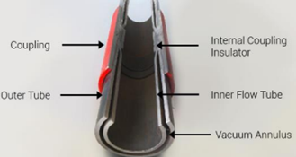

This example is from Helix Offshore Services
VIT is constructed using two concentric tubing strings of different diameters, with the annulus between them sealed by welding, the thin layer of air between the layers is evacuated with a vacuum pump creating an insulated jacket.

Link to Vendors Web page for further information of this technology:
Link: Vacuum Insulated Tubing | Pressure Control Equipment (helixoil.com)

